Virgil Baker
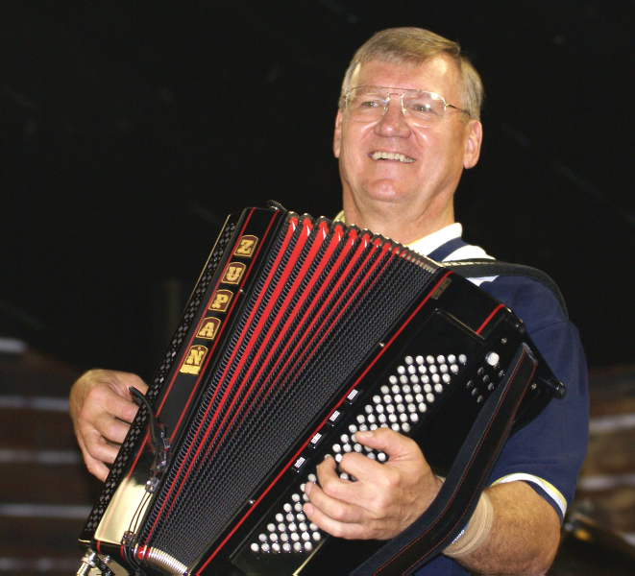

Mr. Just 4 Fun!

It’s just a simple fact. When fun loving people with fond memories and good live music are brought together, you have all the ingredients for a party. Such is the magic of music in creating a mood of joy and celebration in audiences of all ages... and that’s what “Mr. Just 4 Fun” is all about!
A promoter, composer, recording artist, and "achievement" inductee into both the Michigan Music Hall of Fame & Michigan State Polka Music Hall of Fame, his "family-friendly" music repertoire has come to be one that both young and old alike not only appreciate, but actively seek out, as evidenced by his "following" throughout the Midwest.
He, often accompanied by the Just 4 Fun Band, has shared the stage with Frankie Yankovic, Jimmy Sturr, The Four Tops, The Coasters, Ray Price, in addition to numerous less known but equally talented entertainers throughout the U.S. He has the admiration and respect of audiences from Canada to Florida, & California to New York. His Just 4 Fun Band, has appeared at casinos in Nevada, Arizona, Wisconsin, and Michigan.
A repeat performer at Frankenmuth’s Bavarian Inn, Gaylord Michigan’s Blocktober Fest, The Michigan Waterways Fest, many Oktober Fests & Charity Events throughout the Mid-West. The Just 4 Fun Band can also be seen on RFD-TV’s Mollie “B” & Big Joe Polka Shows, broadcast on the Dish, Direct TV, You-Tube as well as on Independent Cable TV Networks.
For Bookings or Information contact:
Virgil Baker,
2431 Forest Hill Ave SE, Grand Rapids, MI 40546 - 616-706-0347
Virgil_baker@sbcglobal.net

